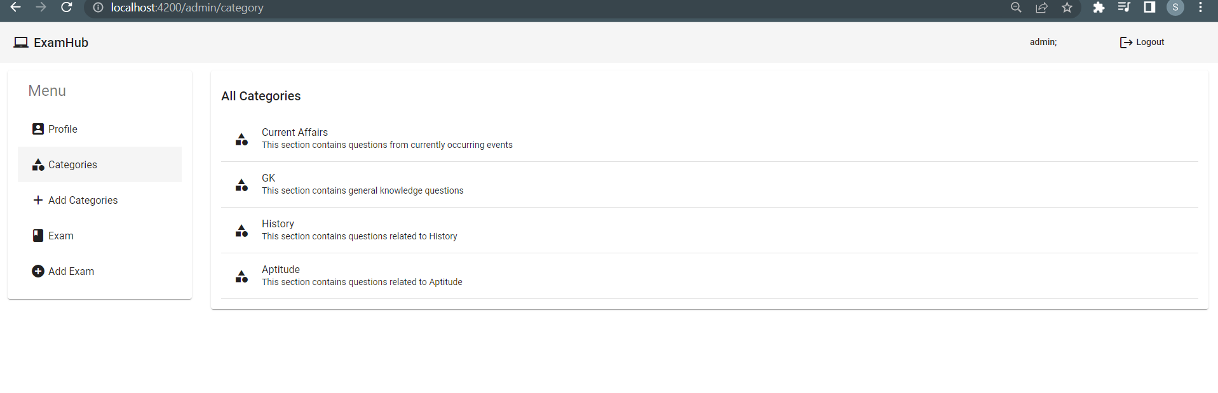

Sidebar.component.html –

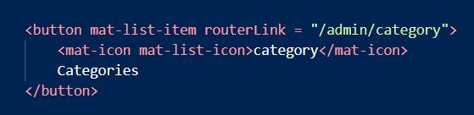

App-routing.module.ts –

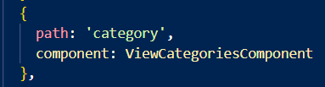

View-categories.component.html –

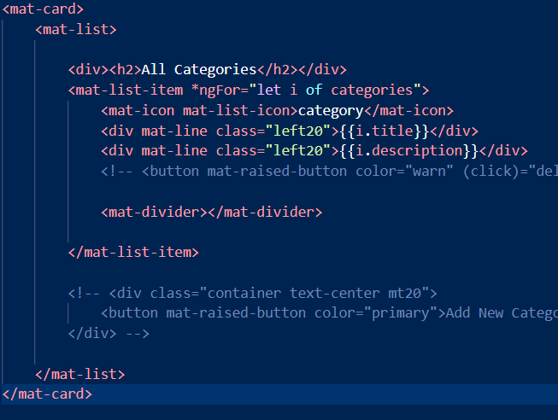

View-categories.component.ts –

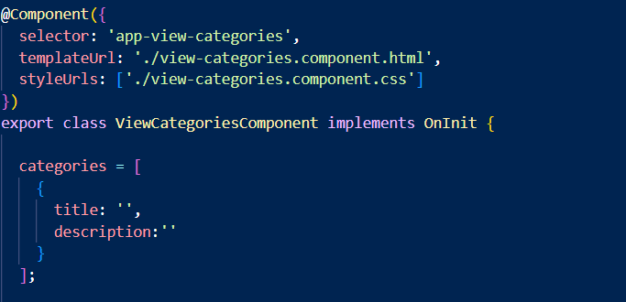

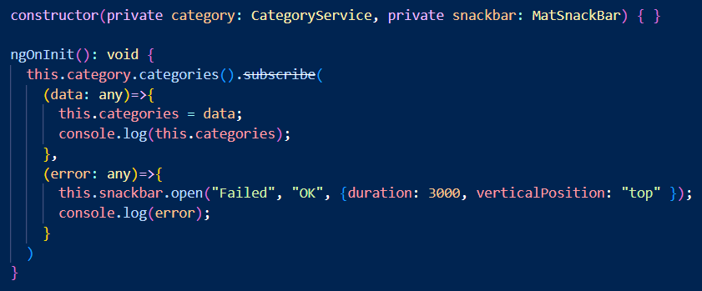

Category.service.ts

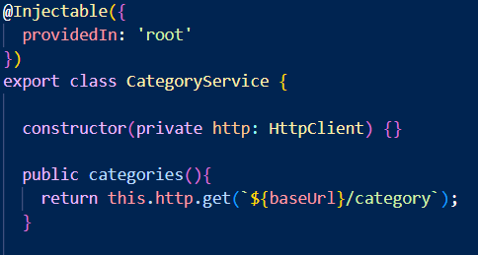

CategoryController –

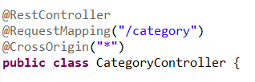

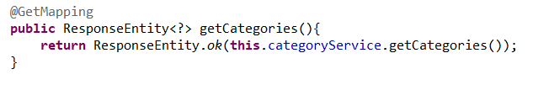

CategoryServiceImpl –



